Standard Operating Procedure

*Excluder Error While Scaling Up*

## PURPOSE

The purpose of this standard operating procedure (SOP) is to provide a detailed step-by-step procedure to resolve excluder error while scaling up.

## PROCEDURE

1. Check if the error below is seen:

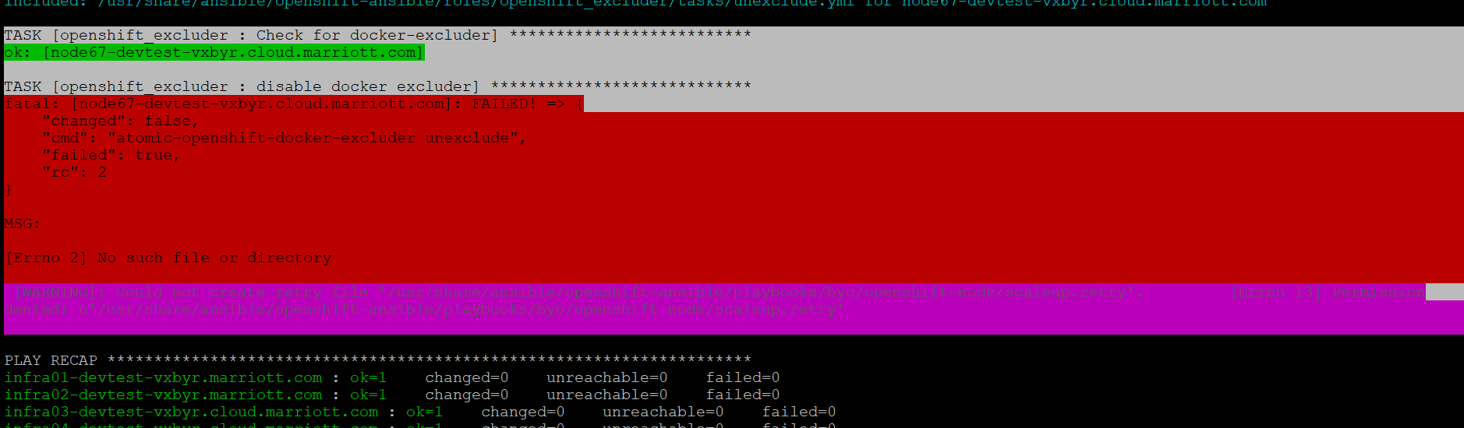

1. Execute this command:

atomic-openshift-docker-excluder unexcluded

1. Put flags below in /etc/ansible/hosts:

openshift_enable_docker_excluder=false

openshift_enable_openshift_excluder=false

1. If there is a package error, rebuild rpm package:
   1. vi /etc/yum.conf
   2. Comment out exclude=

#exclude=

* 1. Remove rpm

rm -f /var/lib/rpm/__db*

/usr/lib/rpm/rpmdb_verify /var/lib/rpm/Packages

* 1. yum clean all

1. Proceed with scale up. When it finishes, comment out excluder flags (step 3) and uncomment exclude section in /etc/yum.conf (steps 4a and 4b) and rebuild rpm db (below is also in RPM Rebuild SOP):
2. Rebuild RPM

rpm --rebuilddb

1. Cleanup everything

yum clean all

## VALIDATION

Follow the validation steps in “Procedure”.

**Document Version Control**

|  |  |  |  |
| --- | --- | --- | --- |
| Version | Effective Date | Reviewed by | Approved by |
| 1.0 | 10/01/2018 | KyungIn Kim | Yashi Kumar |
|  |  |  |  |

Document Modification History & Revision Log

|  |  |  |  |  |  |  |
| --- | --- | --- | --- | --- | --- | --- |
| Version | Date Modified | Revised by | Role | Section Affected | Reference | Remarks |
| 1.0 |  |  |  |  |  |  |
| 1.1 |  |  |  |  |  |  |